0 2 1 0 1 1 1 1 0 0

Sample Output 0

a11472o5t6

Sample Input 0

from 0 to 9.

Print ten space-separated integers in a single line denong the frequency of each digit

Output Format

All the elements of num are made of English alphabets and digits.

1 ≤ len(num) ≤ 1000

Constraints

The rst line contains a string, num which is the given number.

Input Format

given string.

Q1)Given a string, s, consisng of alphabets and digits, nd the frequency of each digit in the

Week 10

Output:

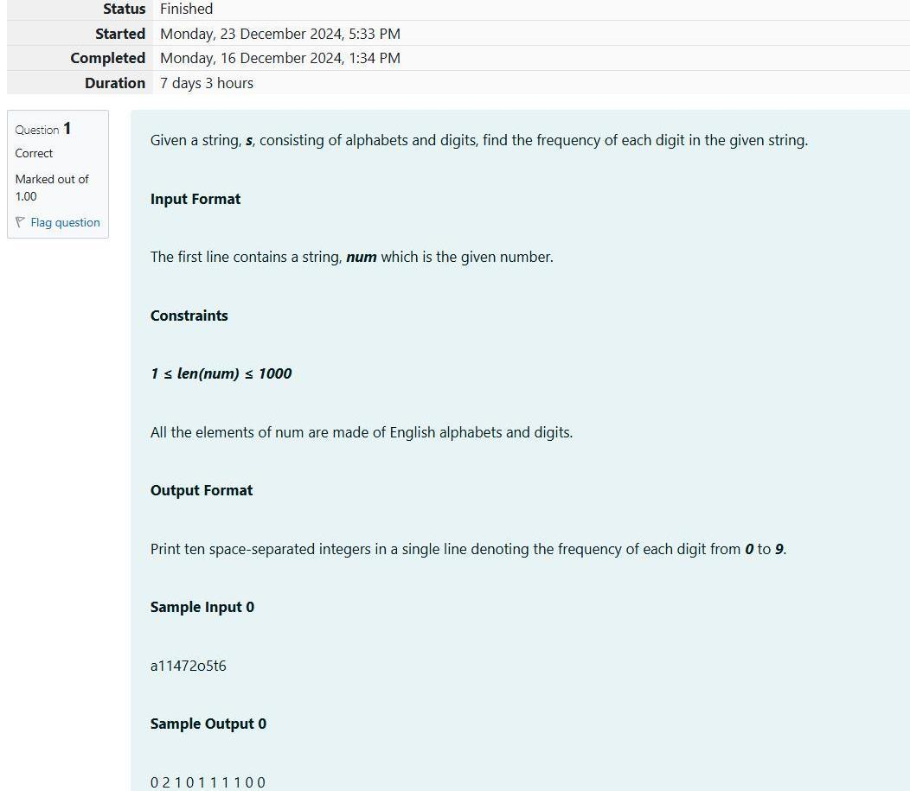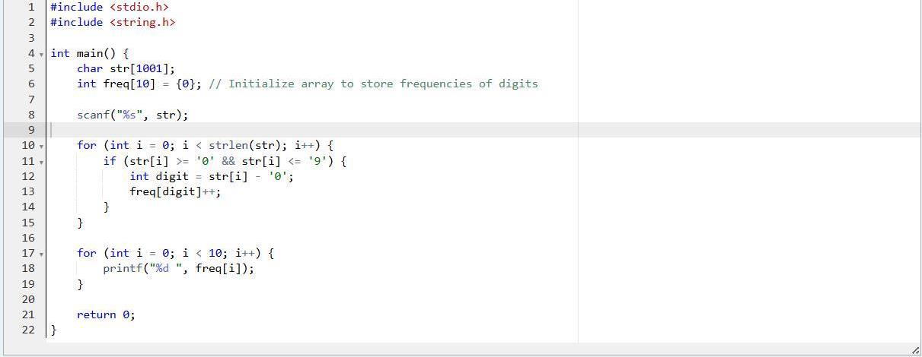

1

2

Sample Output

JHkIsnZtTL

nBBZLaosnm

2

Sample Input

1 ≤ length of string ≤ 105

1 ≤ T ≤ 10

Constraints:

For each test case, print the count in a new line.

Output Format:

(may be lowercase or uppercase) on a tree in the garden.

Each test case consists of only one string, each character of string denong the alphabet

The rst line consists of an integer T denong the number of test cases.

Input Format:

Note: The following leers are vowels: 'A', 'E', 'I', 'O', 'U', 'a', 'e', 'i', 'o' and 'u'.

him the count of such trees in the garden.

vowels on it are not in good state. He decided to take care of them. So, he asked you to tell

tree has an English alphabet on it. While Monk was walking, he noced that all trees with

Q2) Today, Monk went for a walk in a garden. There are many trees in the garden and each

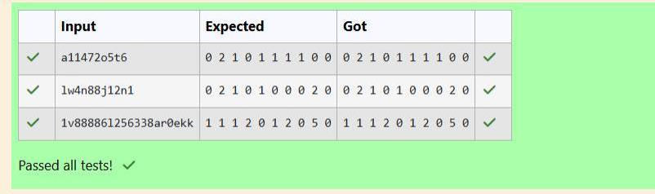

Output:

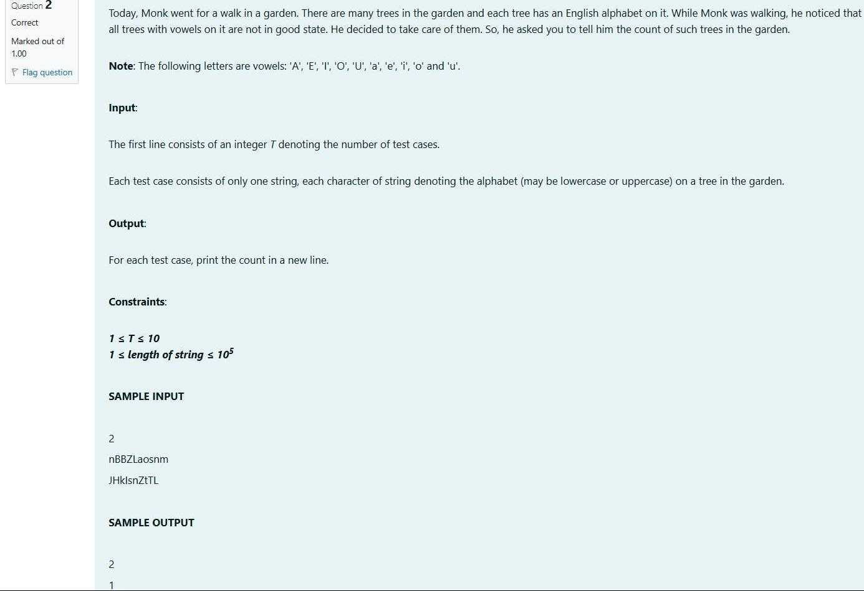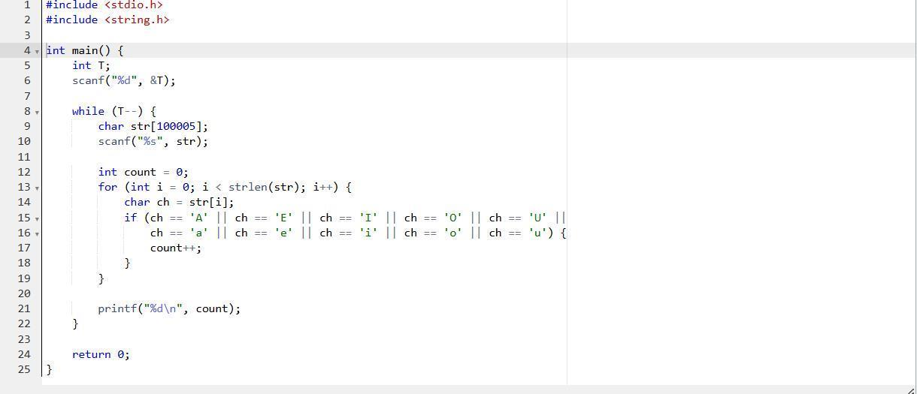

C

is

This

Sample Output

This is C

Sample Input

Print each word of the sentence in a new line.

Output Format

1 ≤ len(s) ≤ 1000

Constraints

The rst and only line contains a sentence, s.

Input Format

Q3)Given a sentence, s, print each word of the sentence in a new line.

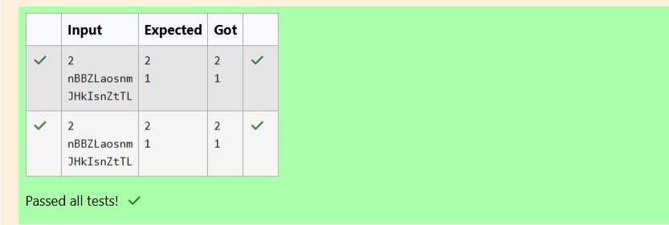

Output:

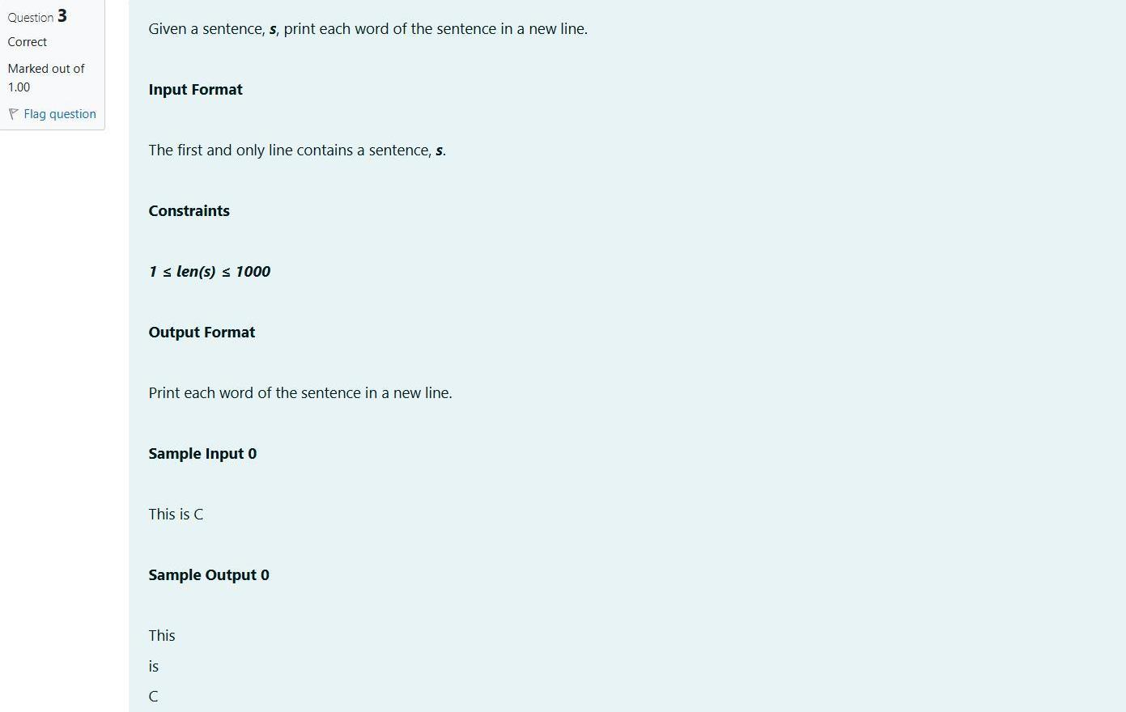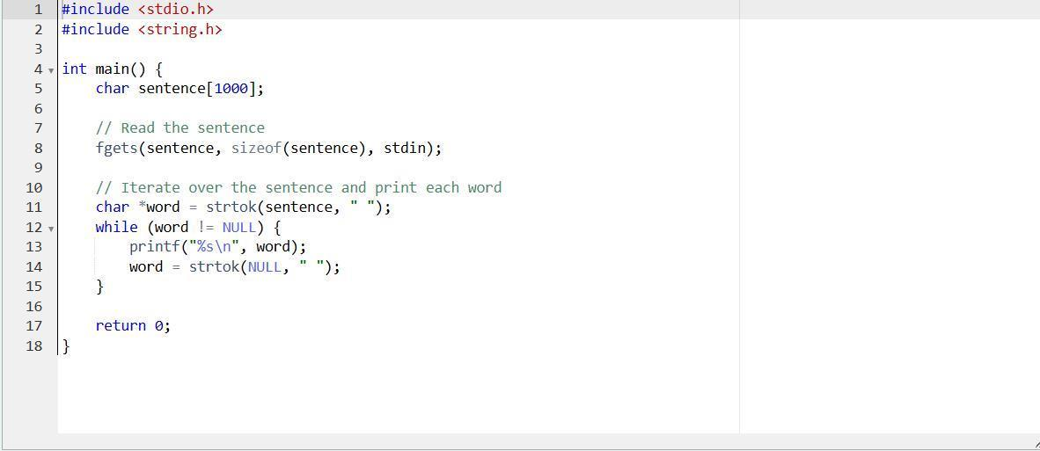

ebcd af

abcdef

4 2

Sample Output

ef

abcd

Sample Input

a and b, respecvely, except that their rst characters are swapped.

In the third line print two strings separated by a space, a' and b'. a' and b' are the same as

In the second line print the string produced by concatenang a and b (a + b).

respecvely.

In the rst line print two space-separated integers, represenng the length of a and b

Output Format

lower-case Lan characters ('a'-'z').

You are given two strings, a and b, separated by a new line. Each string will consist of

Q4) Input Format

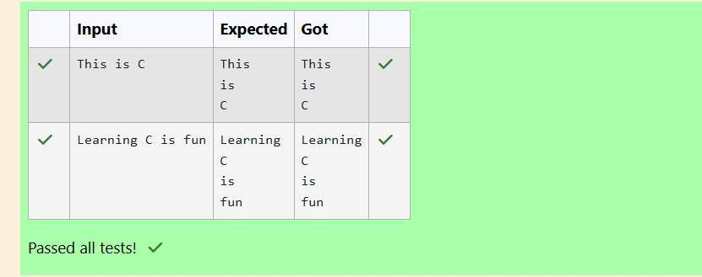

Output:

